**INFOSYS MILESTONE-3**

**Milestone 3 – Infosys Internship**

**TOPIC: Finance Performance Dashboard using Power BI**

**Introduction:**

**Report 1: Sales and Profit Analysis**

This report analyzes sales and profits, focusing on trends, profitability, and discounts.

**1. Measures (DAX Functions)**

1. **Total Sales**
   * **DAX Function:**

Total Sales = SUM (financials [Sales])

* + **Chart:** **Bar Chart**
  + **X-Axis:** Product
  + **Y-Axis:** Total Sales
  + **Purpose:** Compare total sales across products.

1. Total Profit
   * **DAX Function:**

Total Profit = SUM (financials [Profit])

* + **Chart:** **Card**
  + Shows a single value for Total Profit.
  + **Purpose:** Display the overall profitability. This calculates the total profit by summing up the Profit column.

1. Proft Margin
   * **DAX Function:**

Profit Margin = DIVIDE ([Total Profit], [Total Sales], 0)

**Chart:** **Pie Chart**

* + **Legend:** Segment
  + **Values:** Profit Margin
  + **Purpose:** Show profit margin distribution across segments. This calculates the ratio of profit to sales. The DIVIDE function prevents division errors by setting a default value of 0 for cases where sales are 0.

1. Discount Impact on Sales
   * **DAX Function:**

Discount Impact = DIVIDE(SUM(financials[Discounts]), [Total Sales], 0)

* + **Chart:** **Clustered Bar Chart**
  + **X-Axis:** Discount Impact
  + **Y-Axis:** Segment
  + **Purpose:** Visualize how discounts affect sales in different segments.
  + This shows the percentage of discounts relative to total sales.

1. Year-to-Date (YTD) Sales
   * **DAX Function:**

YTD Sales = TOTALYTD ([Total Sales], financials [Date])

* + **Chart:** **Line Chart**
  + **X-Axis:** Date
  + **Y-Axis:** YTD Sales
  + **Purpose:** Show sales trends over time. This calculates cumulative sales from the start of the year up to the current date.

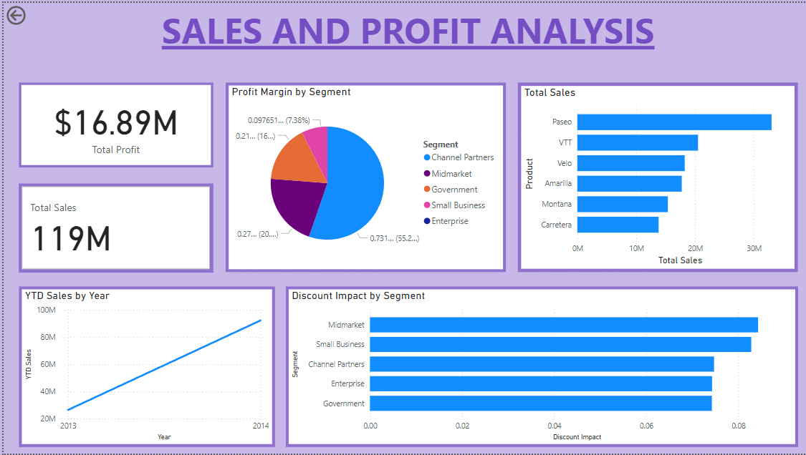

**Report 2: Product Performance and Cost Analysis**

This report focuses on product-level performance, costs, and distribution by country.

1. Total Units Sold
   * **DAX Function:**

Total Units Sold = SUM(financials[Units Sold])

* + **Chart:** **Stacked Bar Chart**
  + **X-Axis:** Product
  + **Y-Axis:** Total Units Sold
  + **Purpose:** Compare units sold across products.
  + Sums up all the units sold from the Units Sold column.

1. Gross Sales

Gross Sales = SUM(financials[Gross Sales])

**DAX Function:**

* **Chart:** **Line Chart**
  + **X-Axis:** Date
  + **Y-Axis:** Gross Sales
  + **Purpose:** Show gross sales trends over time.
  + Sums up gross sales from the Gross Sales column.

1. Cost of Goods Sold (COGS)

Total COGS = SUM (financials [COGS])

**DAX Function:**

**Chart:** **Line Chart**

* + **X-Axis:** Date
  + **Y-Axis:** Total COGS
  + **Purpose:** Compare gross sales and COGS trends.
  + Sums up the total cost of goods sold.

1. Average Sale Price per Unit
2. Avg Sale Price = AVERAGE(financials[Sale Price])

**DAX Function:**

**Chart:** **Card**

* + Shows a single value for Average Sale Price.
  + **Purpose:** Display average pricing across all products.
  + Calculates the average sale price across all units.

1. Sales by Country

Sales by Country = CALCULATE([Total Sales], ALLEXCEPT(financials, financials[Country]))

**DAX Function:**

**Chart:** **Treemap**

* + **Category:** Country
  + **Values:** Sales by Country
  + **Purpose:** Show sales distribution across countries.
  + Filters and calculates sales for each country, ignoring other filters except for the country.

**DASHBOARD:**

**Conclusion:**

